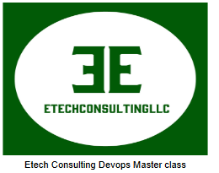

**Engrs: Owusu Agyeman | Elvine Fred | Tabot Dympna | Koge Festus |**

**Felix Fonkeng | Benjamin Adeoye | Fule Esapa**

Jenkins group level project

Problem1:

- What is a Jenkins plugins?

**Jenkins plugins are a piece of program that when installed enables Jenkins to extend its functionalities beyond its initial configurations**

- Name 5 jenkins plugins and their use cases

- What is the differences between scripted pipeline and declarative pipeline?

- Use generic syntax to demo scripted and declarative pipeline as code

- What is a stage-level variable and how is it different from top-level variables?

- What informations does Jenkins need to integrate with github platform?

- How do inject script into your pipeline?

- What are the similarities between a dependency and a plugin?

- How do you configure service account credentials for Jenkins?

Problem2:

- Build an N-STAGE Jenkins pipeline where N=number of group members such that each stage should represent members name

- Use the git flow best practice and add a ReadMe file on your steps to contribute to a project

- Each member should write a simple two steps of (ps -ef and sudo systemctl status Jenkins)